**Class Diagram of a System**

Let us consider a simplified Banking System.

A bank has many branches. In each zone, one branch is designated as the zonal head office that supervises the other branches in that zone. Each branch can have multiple accounts and loans. An account may be either a savings account or a current account. A customer may open both a savings account and a current account. However, a customer must not have more than one savings account or current account. A customer may also procure loans from the bank.

The following figure shows the corresponding class diagram.

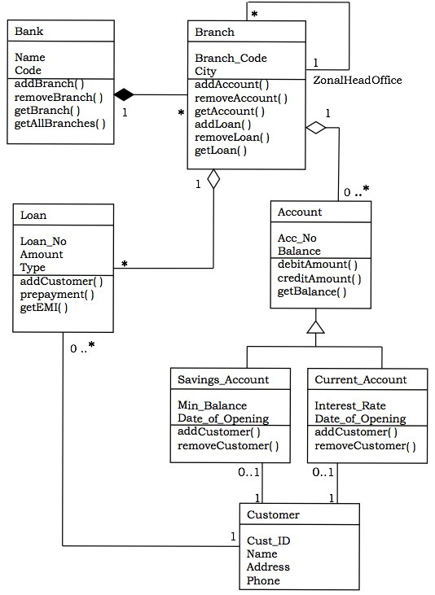

**Classes in the system**

Bank, Branch, Account, Savings Account, Current Account, Loan, and Customer.

**Relationships**

* **A Bank “has–a” number of Branches** − composition, one–to–many
* **A Branch with role Zonal Head Office supervises other Branches** − unary association, one–to-many
* **A Branch “has–a” number of accounts** − aggregation, one–to–many

From the class Account, two classes have inherited, namely, Savings Account and Current Account.

* **A Customer can have one Current Account** − association, one–to–one
* **A Customer can have one Savings Account** − association, one–to–one
* **A Branch “has–a” number of Loans** − aggregation, one–to–many
* **A Customer can take many loans** − association, one–to–many